Chapter 1

Introduction

  - Background and Basics
Internet of things, or IoT, is a system of interrelated ”things” that are provided with unique identifiers and the ability to transfer data over a network without requiring human-to-human or human-to-computer interaction. These ”things” could be computing devices, mechanical and digital machines such as built in sensors, monitors etc.
A good example of a network of IoT devices is the security system implemented by various locations which include, CCTV cameras, motion sensors, automatic locks, smoke detectors, temperature sensors etc.
IOT devices are becoming pervasive. They are used extensively in a lot of fields and their utility is just going to keep increasing. IOT devices help to automate things, reduce labour costs and facilitate smart living.
Hence, it is important to build an optimal system that can provide proper safety and security measures for IOT devices.
An intrusion detection system is one such system that can be a building block in making the IOT network as secure as possible. An intrusion detection system is a system that passively monitors the data exchange in the network and of the network with externals entities and looks for malicious activities that can be classified as an intrusion or attack. It then notifies the user or sends a notification to some other system which may or may not take action against the detected intruder. Simply put, if the network of devices is a home, an intrusion detection system is a CCTV camera.
Also, a step up from just an intrusion detection system is an anomaly based intrusion detection system. This type of system creates a profile of normal behaviour, and any activity that falls outside of the normal category is marked as anomalous. Anomaly based system is better suited to defend the system against zero-day attacks.
There are certain challenges while building this system which are specific to IOT devices. For example, the low computational powers and limited amount of resources (such as space/memory). The IDS system should be build keeping in mind all these challenges and they should be overcome in the most efficient manner.

  - Literature Survey

Table 1.1 Literature Survey

Title | Year | Publication | Data -set | HIDS /NIDS | Anomaly /Signa- ture | Model used | Drawbacks
Anomaly based intrusion de- tection system through feature selection analysis and building hybrid efficient model | 2018 | Journal of computational science 25(2018) 152-160 | NSL- KDD | NIDS | Anomaly | Hybrid | Not imple- mented for iot Devices
Distributed at-  tack  scheme  deep  approach for Internet of Things  detection using learning | 2017 | Future Genera- tion Computer Systems (2017) | NSL- KDD | NIDS, fog | Signature | Deep learning | signature based, new attacks cannot be recognized
Towards Ma- chine Learning Based IoT Intrusion Detection Service | 2018 | Springer In- ternational Publishing AG, part of Springer Nature 2018 | UNSW-NB15 | NIDS,  Cloud | Anomaly | Neural net- work, random forest | uses cloud computing, which increases the resource require- ments
Host based intrusion de- tection system with combined CNN/RNN model | 2019 | Springer Nature Switzer- land AG 2019 | ADFA- LD | HIDS | Anomaly | RNN with GRU | HIDS, and not NIDS Perfor- mance doesnt match ensemble models
Anomaly-based intrusion detection of iot device sensor data using provenance graphs | 2018 | 1st Inter- national Workshop on Security and Privacy for the Internet of Things (IoTSec) | longi -tudinal data  on the thermal | HIDS | Anomaly | Prov -enance graphs | Works with offline data, doesn’t work with real time data

  - Project Undertaken
1.3.1 Problem Definition
Design and implement an anomaly Based Intrusion Detection System in IoT Networks using Random Forest which will passively monitor the IoT network traffic and alerts the user for any intrusion detected.
1.3.2 Scope Statement
Product can be used in any IOT network for the purpose of the security. Since use of IOT devices is increasing, day by day, in all fields and sector, there is an increasing need for security mechanisms designed specifically for IOT devices or networks. The main function of the IDS system is to detect anomalous behavior that can be caused by the attacks. So it can be deployed anywhere where we need security measures in place to protect IOT devices.
  - Organization of Project Report
The project report is organized as follows:
1.4.1 Chapter 1
Chapter 1 is Introduction. It gives the background and basics of the project. It is followed by a detailed literature survey of similar works in the past. Problem statement and scope of the project are deﬁned as well.
1.4.2 Chapter 2
Chapter 2 is Project Planning and Management. It has details of the system requirement speciﬁcations which include functional and non-functional requirements, system overview, deployment environment, external interface and other requirements. The project process model applicable to this project is also mentioned. Cost estimate analysis and time line scheduling is done as well.
1.4.3 Chapter 3
Chapter 3 is Analysis and Design. It consists of idea matrix, mathematical model and feasibility analysis. All the analytical and design diagrams are also included in this chapter. These diagrams include use case diagram, activity diagram, architecture diagram, class diagram, ER diagram, sequence diagram, state transition diagram and deployment diagram.
1.4.4 Chapter 4
Chapter 4 is Implementation and coding. This explains the details of the working of the system as a whole along with module wise operations. It provides an insight of how each module works individually. It has important code snippets of all the modules. It shows screenshots that help visualize the system better.
1.4.5 Chapter 5
Chapter 5 is Testing. In this chapter, test cases regarding diﬀerent types of testing are given. The types of testing included are unit testing, integration testing and acceptance testing.

Chapter 2

Project Planning and Management

2.1 Introduction

This chapter covers the project planning and management details. It also covers System Requirement specifications. SRS is considered as the base for the effort estimations and project scheduling.

2.2 System Requirement Specification (SRS)

2.2.1 Detail System Requirement Speciﬁcation

2.2.1.1 System Overview

Product Perspective
The system has been inspired by the already existing intrusion detection systems which attempt to protect the home-network against attacks and intrusions. We are taking these pre-existing models and combining them to get additional advantages and reduce the downsides as much as possible. Till date, there have been very few attempts at making an IDS for IOT devices. Most of the IDS present in the market cater to non-IDS networks. We are taking the principles of these IDS systems and modifying them as per requirement of an IOT network.

Product Functions
1) User authentication
2) Data connection establishment
3) Intrusion detection analysis
4) Attack Notification
5) Dashboard
6) Network log analysis
7) Visualizations

User Classes and Characteristics
Factories and companies employing a network of IOT devices. Usually the IOT networks for these users are larger and require higher level security systems as economic factors are involved. Residential habitants employing network of IOT devices. Includes home-IOT networks (smart homes), or residential society IOT networks like CCTVs, smoke detectors, ﬁre alarms etc. These networks are usually smaller than the previous.

Operating Environment
The system will be implemented on Linux. Python is used for programming the backend using Django Framework. Languages such as Python and Sqlite and platform like apache server are used for database and connection. Libraries like sklearn, pandas etc. will be used. For real life implementation, IOT data will be connected from Tshark.

Design and Implementation Constraints
• The user will be notiﬁed through a web app, which should be installed on their system.
• All the nodes of the IOT network should be connected to the main server where the processing is to take place.
• The device to be notiﬁed also has to be part of the given network.
• Processing time should be as low as possible.
• Backend should be connected to database.
• Wifi (802.11) supported on all the IOT devices.

User Documentation
• User manual.

Assumptions and Dependencies
• We are assuming that the machine has the required resources (memory and processing power etc.) and capabilities to run the system.
• The user has updated system. We are assuming that the system has the required packages and dependencies (such as Django and Xampp) to run the system.

2.2.1.2 Functional Requirements(System Features)

2.2.1.2.1 Sensing of the data using ultrasonic sensor
Description and Priority
First, sensors or devices collect data from their environment. The benefit of this feature is much larger and the cost of this feature is reasonably low. Only risk of this feature is that it sometimes may not work as intended.
Stimulus/Response Sequences
Once the IOT device is started, distance data is processed and sent from the node to the apache server. The network traffic is monitored using Tshark and dumped into a csv file. The python script in the backend reads this csv file, preprocesses it and feeds it to the ML model. If an intrusion is detected, it is notified to the user on the front end.
Functional Requirements
IOT sensor node equipped with Arduino and nodemcu.

2.2.1.2.2 Connectivity
Description and Priority
The sensors/devices are to be connected to the network through wifi. This feature is of high priority because the sensed data needs to be processed further. The data will be processed only if it gets proper way to reach to the server. Only risk of this feature is that it can sometimes not send the data to the server.
Stimulus/Response Sequences
Data sensed is sent to the server.
Functional Requirements
Apache server of the network along with wifi module.

2.2.1.2.3 Data Processing
Description and Priority
Once the data gets to the server, software performs processing on it. Here IDS software is used to determine the category of the attack. This feature is of high priority because this is the main objective behind selecting this project. Only risk of this feature is that it can sometimes not categorize the attack perfectly.
Stimulus/Response Sequences
In response, it will determine whether the attack was normal or malicious.
Functional Requirements
IDS software.

2.2.1.2.4 User Interface
Description and Priority
Next, the information is made useful to the end-user in some way. This is an alert to the user (text, notification, etc.). This feature is of medium priority. Only risk of this feature is that it can sometimes not work as intended.
Stimulus/Response Sequences
In response it will give notification of the attack on the GUI.
Functional Requirements
GUI

2.2.1.3 Non- Functional Requirements

Performance Requirements
The data transfer from the IOT node to the apache server should take as little time as possible for proper real time functioning of the system. Also, the processing of the data should be fast enough so as to give proper result as soon as the attack happens, i.e. the time between the occurrence and detection of the attack should be minimum.

Safety Requirements

The backend could crash resulting in failure of the whole system. If the system takes up all the processing power, that machine could crash. Regular maintenance of the networking components, such as checking the proper functioning of the Arduino, ultrasonic sensor and nodemcu should be done.

Security Requirements

User need to signup first and then login to get access to the system, in this case users data should be protected. Systems should be secure against unauthorized access to any of their data, unauthorized use of them or any of their components. Details regarding IOT devices and their data should also be protected.

Software Quality Attributes

Our software has many quality attribute that are given below: -

• Availability: This software is freely available to all users. The availability of the software is easy for everyone.
• Maintainability: After the deployment of the project if any error occurs then it can be easily maintained by the software developer.
• Reliability: The performance of the software is better which will increase the reliability of the Software.
• User Friendly: Since, the software is a GUI application, the output generated is much user friendly in its behavior.
• Integrity: Integrity refers to the extent to which access to software or data by unauthorized persons can be controlled.
• Security: Users are authenticated using many security phases so reliable security is provided.

2.2.1.4 Deployment Environment

Software Requirements-
1) Python 3 - Coding language used in our project
2) Django Framework - Used for backend work
3) Node - Used for executing JavaScript code outside of a web browser
4) Npm - Used as package manager for the Node JavaScript platform
5) React.js - Used for frontend work
6) Sqlite - Used for database
7) Xampp server - Used for storing network data
8) Tshark - Used for network data analysis

Hardware Requirements-
1) Arduino - For reading inputs of ultrasonic sensor and turn it into an output as distance data
2) Nodemcu - Node Microcontroller Unit used to build IOT network
3) Ultrasonic sensor - Used for collecting sensor data
4) Connecting wires - Used for connecting nodemcu to Arduino and ultrasonic sensor

2.2.1.5 External Interface Requirements
User Interfaces
- User Signup page
• Username
• Email id
• Password
• Signup(Button)

- User login page
• Username
• Password
• Login(Button)

- User Notification page
Notifies when the network is under attack or some anomalous activity is detected.

- User dashboard page
Displays ultrasonic data from php script in animated format on web page.

- User Network Logs page
Displays the real time Tshark data in table format.

- User Visualisations page
Displays graphs and confusion matrix for various types of data.

Hardware Interfaces

Hardware interfaces for a web application will run on Linux, Windows or Mac. For connection of IOT node to the apache server will require a network. For a larger model, the network and servers will increase. Here IOT network consists of ultrasonic sensor, Arduino and Nodemcu which sends data to the apache server using wifi module.

Software Interfaces

- Operating system –
We have chosen Linux operating system because of its user friendly features, benefits of security and control without complexity and unrealistic costs.
- Database –
Sqlite using apache server
- Python –
Django is used to program and implement the backend and React.js used to create web pages for frontend. IDS is designed to run in the background of an IoT network, where distance data is processed and sent from the node to the apache server. The network traffic is monitored using Tshark and dumped into a csv file. The python script in the backend reads this csv file, preprocesses it and feeds it to the ML model. If an intrusion is detected, it is notified to the user on the front end.

Communications Interfaces

1) Web application runs on a web browser
2) HTTP is used for notification system
3) Wifi module is used for data transfer from IOT node to the apache server.

      - Other Requirements

- Configuration –
Systems should be configurable for detection and reaction, as feasible for alerts, updates, protocol and port coverage, and detection-threshold levels. Systems should be configurable treat identified IP or other network addresses exceptionally; for example, configurable to never block or shun network activity from one or more IP addresses.
- System Updates –
These capabilities should be engineered in such a manner as to allow updates during operational use of the products without disruption.
- Ease of use –
Operator console should not require undue expertise to operate; experts may reside external to operator staff.

  - Project Process Modeling

Iterative waterfall model is the best suited for this project. Iterative waterfall model can be thought of as incorporating the necessary changes to the classical waterfall model to make it usable in practical software development projects. It is almost same as the classical waterfall model except some changes are made to increase the efficiency of the software development.
The iterative waterfall model provides feedback paths from every phase to its preceding phases, which is the main difference from the classical waterfall model. In our project, every phase is well defined and to be executed one after the other sequentially, like the waterfall model. But if need be, there is space for going back to previous stages making changes. Hence, iterative waterfall is to be used for this project.

  - Cost & Efforts Estimates

As per the basic COCOMO cost estimation formula projected cost for our product, Development Effort = a1 x (KLOC) a2 PM
= 2.4 * (4) 1.05
= 10 Person Months (approx)
Nominal development time = b1 x (Effort) b2 Months
= 2.5 * (10) 0.38
= 6 months (approx)
Cost required to develop the product = NDT x Average salary per month x
members
= 6 * 5000 * 4
= Rs 120,000/-
Where,
KLOC is the estimated size of the software product expressed in Kilo Lines of Code
a1, a2, b1, b2 are constants for each category of software products.

  - Project Scheduling

Time line chart

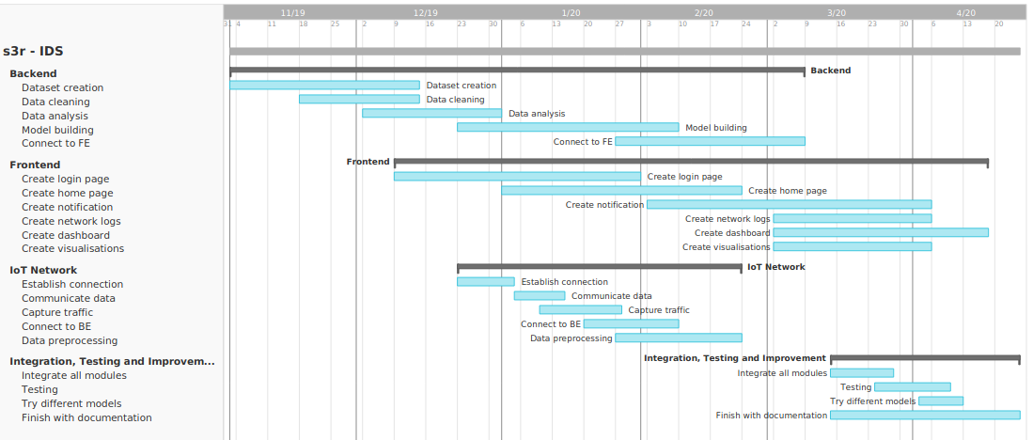
Fig 2.1 Time line chart

Chapter 3

Analysis and Design

3.1 Introduction

This chapter covers the analysis and design of the considered system.

3.2 Idea Matrix

Table 3.1 Idea Matrix
Idea Matrix
Increase | 1)It increases Network security  2)It increases network monitoring | 1)Network security  2)Network monitoring
Improve | 1)It improves zero-day attack detection  2)Improves IoT security  3)Improves awareness of user about network intrusions | 1)Unknown attacks  2)IoT security  3)User awareness
Ignore | 1)It ignores the normal behavior in the network | 1)Normal behavior
Deliver | 1)It delivers efficient intrusion detection system for IoT devices | 1)IoT security
Document | 1)Documentation of the project for researchers to understand and improve on the project in the future. | 1)Project documentation
Decrease | 1)It decreases efforts taken to create signatures | 1)Effort
Educate | 1) Educate project members with security concepts, machine learning, Tshark, web sockets, scripting, UI development  2)Educate user | 1)Project members  2)User
Evaluate | 1)Continuously monitor network traffic for intrusions  2)Evaluate packets to determine if there is an intrusion | 1)Network Traffic  2)Packets
Experiment | 1)Experiment on different types of attacks  2)Experiment on different types of ML models | 1)Attacks  2)ML Models
Accelerate | 1)It increases the processing speed by using a separate device instead of the IoT device itself | 1)Processing speed
Analysis | 1)It analyses detected anomalies to deter- mine what type of attack it is | 1)Category of attack
Advertise | 1)Advertise about IoT security and need of an IDS  2)Create a GitHub page, which will include code, documentation and process | 1)Security awareness  2) GitHub

3.3 Mathematical Model

Let S be the solution set for the given problem statement.
S = { Input, Function, Output, Terminate, Success, Failure }.
Where,
Input = Input to the System.
Function = Functions of the system.
Output = Output of the system.
Terminate = Terminating Condition of the System.
Success = Success cases for the System.
Failure = Failure cases for the system.
1. Input = { UserName, Password, Data Packets }
a. UserName :- user id
b. Password : user password
c. Data Packets:- A data packet is a unit of data made into a single package that travels along a given network path.
2. Function = { Login auth, Network connection, train test, intrusion detection, Notification }
a. Login auth: This function will take Username and Password as the input and gives the authorization rights to the user accordingly.
IF Y = F(X) is the login auth function then
X: - Username and Password taken as an input.
Y: - Authorization rights of a user.
b. Network connection = This function will take port number, IP address as an input to give the status of the connection network.
IF Y=F(X) is the Network Connection Function, then
X:- Inputs to setup a network, connecting to a device, routing the incoming data and device configuration.
Y:- Status of the network connection.
c. train test: This function will take features as an input to give the accuracy of the model and further it will be turned to improve the accuracy of the model. Random Forest has been used as a Machine learning algorithm for building the model.
IF Y=F(X) is the function to test and train the model then,
X:- Features of the self created dataset as an input.
Y:- Accuracy of the model
d. intrusion detection : This function will take features like frame number, frame time, frame length, source mac address, destination mac address, source IP address, destination IP address, IP protocol, IP length, TCP length, TCP source port, TCP destination port, packet info as an input and notifies the user the system for the intrusion.

• Random Forest Classifier has been used for the building and implementing the model.
Basically, a random forest is an average of tree estimators. As with nonparametric regression, simple and interpretable classifiers can be derived by partitioning the range of X.
Let n = A1, . . . , AN be a partition of X. Let Aj be the partition element that contains x. Then h(x) = 1 if XiAj Yi XiAj (1 Yi) and h(x) = 0 otherwise.
We conclude that the corresponding classification risk satisfies R(h) R(h) = O(n1/(d+2)).
Trees are useful for their simplicity and interpretability. But the prediction error can be reduced by combining many trees.
These are bagged trees except that we also choose random subsets of features for each tree. The estimator can be written as
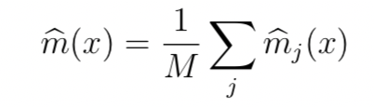
where mj is a tree estimator based on a subsample (or bootstrap) of size a using p randomly selected features. The trees are usually required to have some number k of observations in the leaves. There are three tuning parameters: a, p and k. You could also think of M as a tuning parameter but generally we can think of M as tending to . For each tree, we can estimate the prediction error on the un-used data. (The tree is built on a subsample.)
Averaging these prediction errors gives an estimate called the out-of-bag error estimate.
IF Y=F(X) is the function then,
X: frame number, frame time, frame length, source mac address, destination mac address, source IP address, destination IP address, IP protocol, IP length, TCP length, TCP source port, TCP destination port, packet info as an input
Y: Classification – attack/normal.
e. Notification: This function takes the input which is provided by the function (intrusion detection) and notifies the user.
IF Y=F(X) is the function then,
X: Output of the function(intrusion detection).
Y: Intrusion message to the user.
3. Output = { display intrusion msg }
a. display intrusion msg : display error message if any intrusion occurs.
4. Intermediate Results
a. Successful working of module.
b. Successful Working of Network.
c. Successful User authentication.
5. Terminate = { Invalid details, Network failure, Timeout}
a. Invalid User Authentication.
b. Network failure
c. timeout
6. Success
a. Successful user login.
b. Successful connection establishment of nodes and ids.
c. Successful detection of intrusion.
d. Displaying the results.
e. Appropriate error messages in case of invalid input.
7. Failure
a. Web app Failure.
b. Hardware faults.
c. Network establishment failure.
d. Not displaying required results.

3.4 Feasibility Analysis

The problem is to detect an intrusion in a IoT network. The main objective of our project is to provide a real-time solution for any possible intrusions. In the proposed system, we are planning to use anomaly-based detection system. The anomaly-based intrusion detection system comes into eﬀect when detecting newer attacks, that are not ﬁltered by the ﬁrewall. Random Forest is an ensemble model of decision trees.
Training Complexity: O((nˆ2)pntrees) Prediction Complexity: O(pntrees)
Calling n the number of training sample, p the number of features, ntrees the number of trees (for methods based on various trees), where, n= 21000 (Approx) p = 17 ntress= 4
Hence O(pntrees) runs in polynomial time complexity. The algorithm falls in P. Hence, the given problem is NP.

3.5 Architecture Diagram

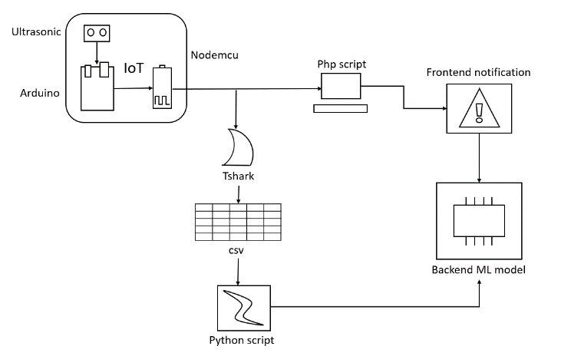
Fig 3.1 Architecture Diagram

3.6 UML Diagrams

3.6.1 Use case diagram

A use case diagram shows the relationship between the user and the different use cases in which the user is involved. The following diagram shows how the user, IoT device and the backend interacts with the system. The user can login/register and view the network details, notifications, etc. while other details are hidden.

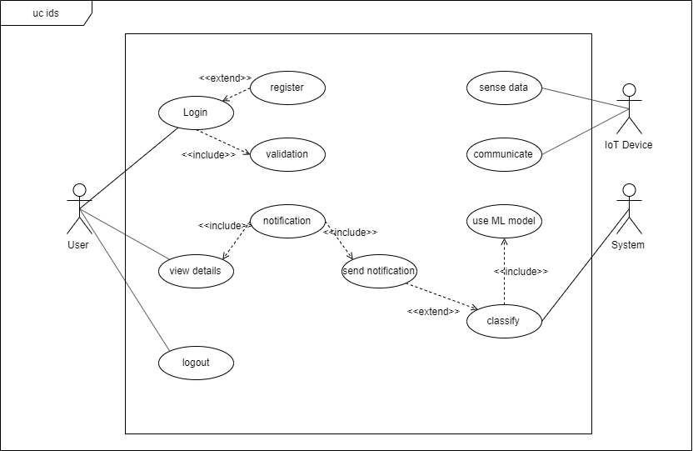
Fig 3.2 Use Case Diagram

3.6.2 Activity Diagram

The activity diagram shows the stepwise flow of activities and actions. Here it explains the flow of the system, how it starts with login/registration. Then it user can perform their regular tasks while the IDS keeps working in the background and notifies the user when an attack is detected.

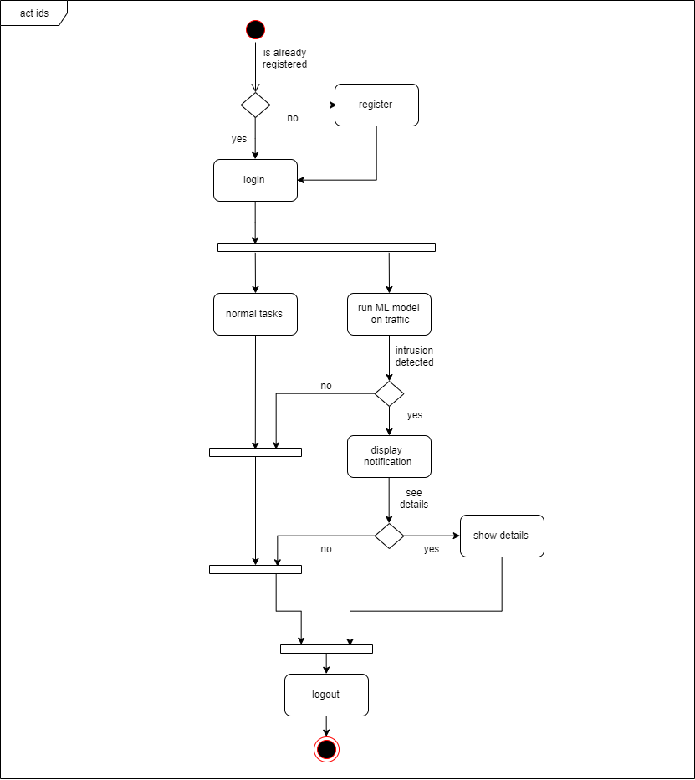
Fig 3.3 Activity Diagram

3.6.3 Class Diagram

A class diagram is a static structure diagram that describes the structure of a system by showing the system's classes, their attributes, operations (or methods), and the relationships among objects. Here it shows the structure of objects such as user, notification, model, etc.

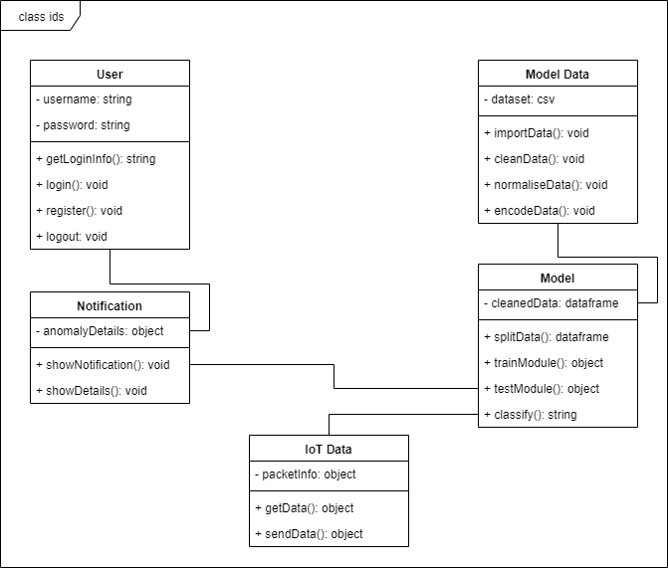
Fig 3.4 Class Diagram

3.6.4 Sequence Diagram

A sequence diagram shows object interactions arranged in time sequence. The following diagram shows the sequence of steps that follows one after the other in the system. It shows when the connection is established and when the model starts giving the intrusion alerts.

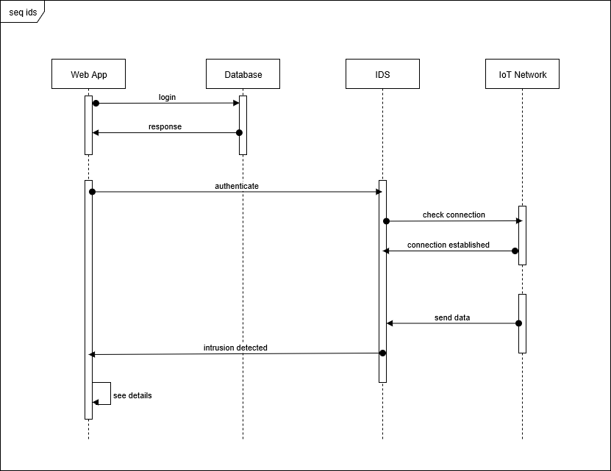
Fig 3.5 Sequence Diagram

3.6.5 Package Diagram

A package diagram in the Unified Modeling Language depicts the dependencies between the packages that make up a model. The diagram explains that the backend is dependent on the IoT network for data. The ML model is dependent on the backend. The GUI is dependent on the ML model for the attack classification to create the notification.

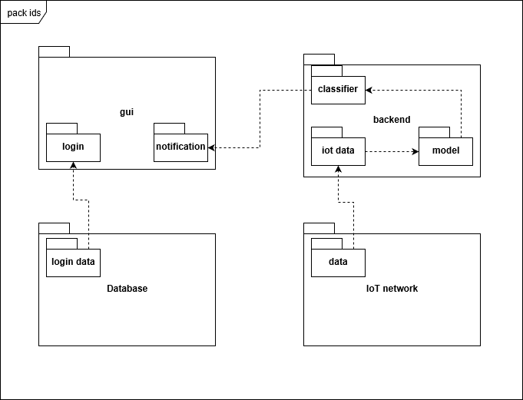
Fig 3.6 Package diagram

3.6.6 State Machine Diagram
UML state machine,[1] also known as UML statechart, is a significantly enhanced realization of the mathematical concept of a finite automaton in computer science applications as expressed in the Unified Modeling Language (UML) notation.
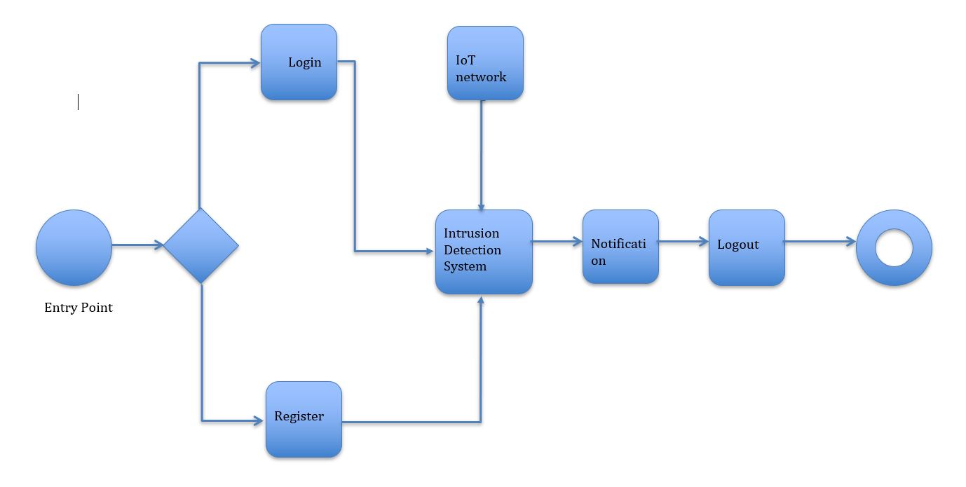
Fig 3.7 State Machine Diagram

3.6.7 Deployment Diagram
A deployment diagram in the Unified Modeling Language models the physical deployment of artifacts on nodes.
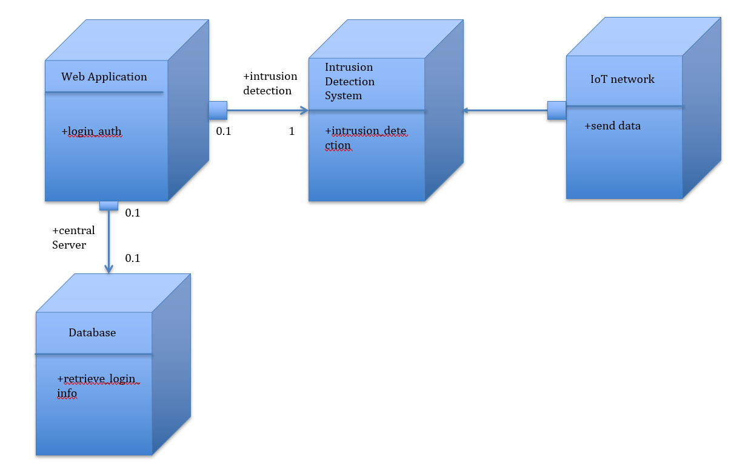

Fig 3.8 Deployment Diagram

3.7 IoT Node Connections Diagram

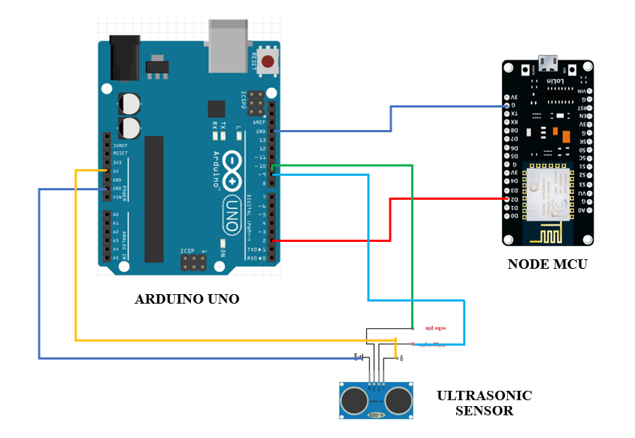
Fig 3.9 IoT Node Connections Diagram

Chapter 4

Implementation and Coding

4.1 Introduction

This chapter covers the role of various subsystems/modules/classes along with implementation details listing of the code for the major functionalities. The system consists of an IoT node (Arduino UNO, Node MCU, Ultrasonic sensor connected together), which sends distance data to the backend on the Apache server. This data is displayed on the GUI of the React.js front end. The network traffic is monitored by the TShark script and dumped in the file.csv. The Django Python backend reads this data in real time, feeds it to the ML model based on Random Forest and classifies it either as normal or attack. This data is sent to the front end and displayed in the form of a notification.

4.2 Module-wise Details

4.2.1 IoT Node
The IoT node consists of 3 devices – Arduino UNO, Node MCU, Ultrasonic sensor.
4.2.1.1 Ultrasonic sensor – Its end goal is to measure distance. It emits ultrasonic waves and receives them.
4.2.1.2 Arduino UNO – This controls the ultrasonic sensor, measures the time between sending and receiving the waves which is used to calculate the distance from the object using the formula-
Distance = duration*0.034/2
4.2.1.3 Node MCU – The distance data is sent from Arduino to Node MCU using a serial communication. This is then sent to the php script on the Apache server by connecting to the wifi network.

4.2.2 TShark Script
TShark is a command line utility, a network packet analyzer that is used to capture packets from a live network and dump the traffic data into file.csv which is later read by the backend Python script. It captures the fields – frame number, frame time, frame length, source mac address, destination mac address, source IP address, destination IP address, IP protocol, IP length, TCP length, TCP source port, TCP destination port, packet info.

4.2.3 Apache Backend
The apache backend has 1 php script – server.php and 1 text file – datastorage.txt.
4.2.3.1 server.php – This php script is used to receive distance data from the IoT node and save it in the datastorage.txt.
4.2.3.2 datastorage.txt – This text file stores the 10 most recent distance values sent from server.php. The older values are deleted by server.php. This data is used by the front end to display graphics in Dashboard.js.

4.2.4 ML model
4.2.4.1 Dataset – The dataset needed to create the ML model was made using traffic data gathered from the TShark script. Multiple attacks (wrong setup, DDOS, Data Type Probing, Scan Attack, MITM) were performed while monitoring the traffic. The records were labeled according to known parameters used to identify particular type of attack.
4.2.4.2 Model Creation – The generated dataset was filtered for erroneous data in dataFilteration.py, resampling was done to deal with the issue of lesser attack data than normal data in resampling.py, then it was divided into training, testing datasets and a Random Forest classifier was trained based on training data in model.py. This was tested using the test data and later optimized. This model has been used in consumers.py in the Django backend for real time attack classification.
This can be better understood from the following sequence diagram.
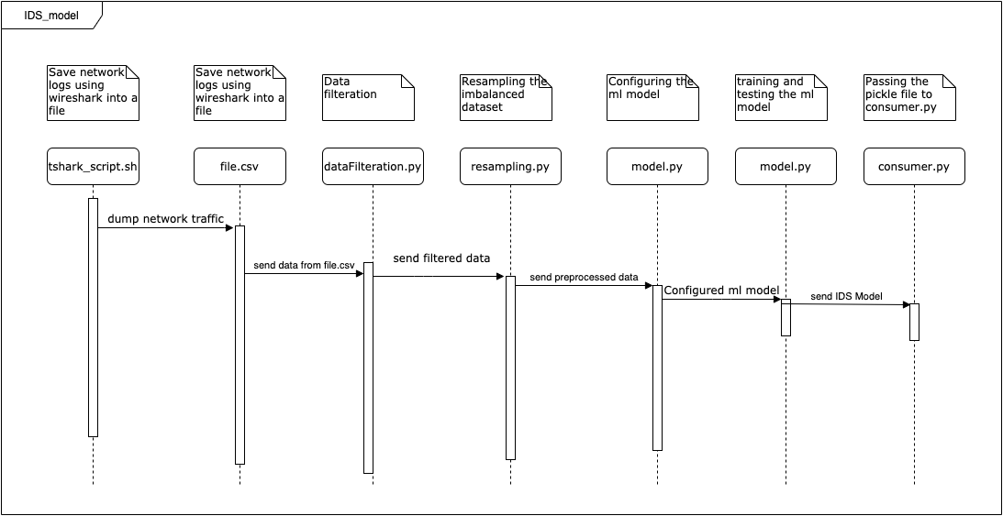
Fig 4.1 ML model module

4.2.5 Notifications
The notification module is responsible for displaying the notification to the user whenever an attack has been detected in the IoT network. A web socket (attackNotif ws) is created between the React.js front end and Django backend to send notification data from BE to FE whenever an attack is detected. The ws starts the real time read loop in consumers.py which takes the data from file.csv, processes it and constantly keeps feeding to the ML model. The model makes classification (normal or attack) in real time and sends a notification if an attack is detected. This notification is displayed in the front end. This can be better understood from the following sequence diagram.
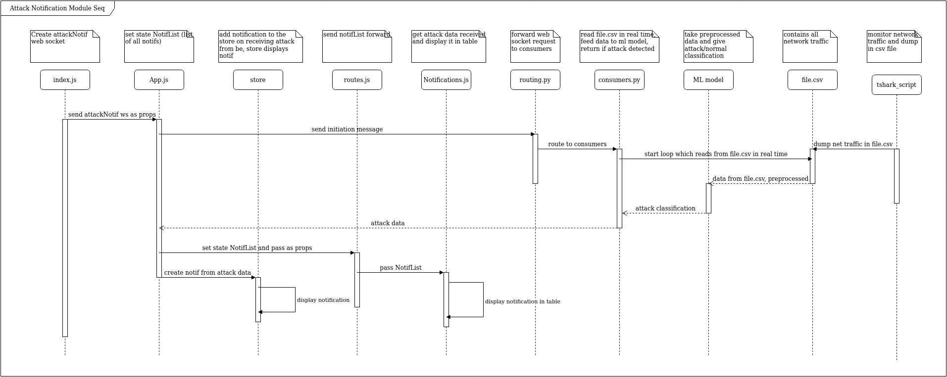
Fig 4.2 Notifications Module

4.2.6 Network Logs
The network logs module is used to display the traffic in the IoT network in real time. Similar to the notifications module, the web socket is created which initializes the loop in consumers.py that fetches traffic data from file.csv in real time. This data is sent to the FE where it is displayed. It updates in real time so the user can monitor IoT network traffic. This can be better understood from the following sequence diagram.
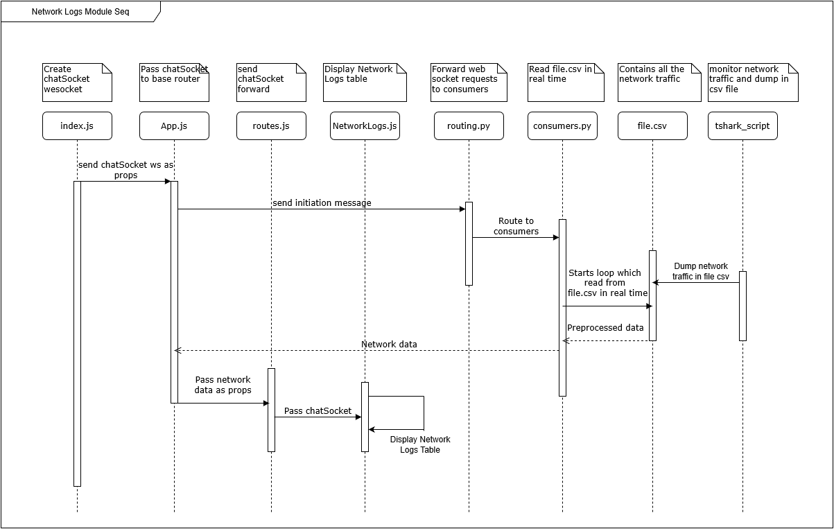
Fig 4.3 Network Logs Module

4.2.7 Dashboard
The dashboard module displays the distance data received from the IoT node with the help of graphics, thereby simulating the applications of the IoT network. A web socket is created between the FE and the php script websockets.php. An initiation message is sent which triggers the loop in the php script which reads the data from datastorage.txt and constantly sends this data to Dashboard.js where the node activity is shown. This can be better understood from the following sequence diagram.
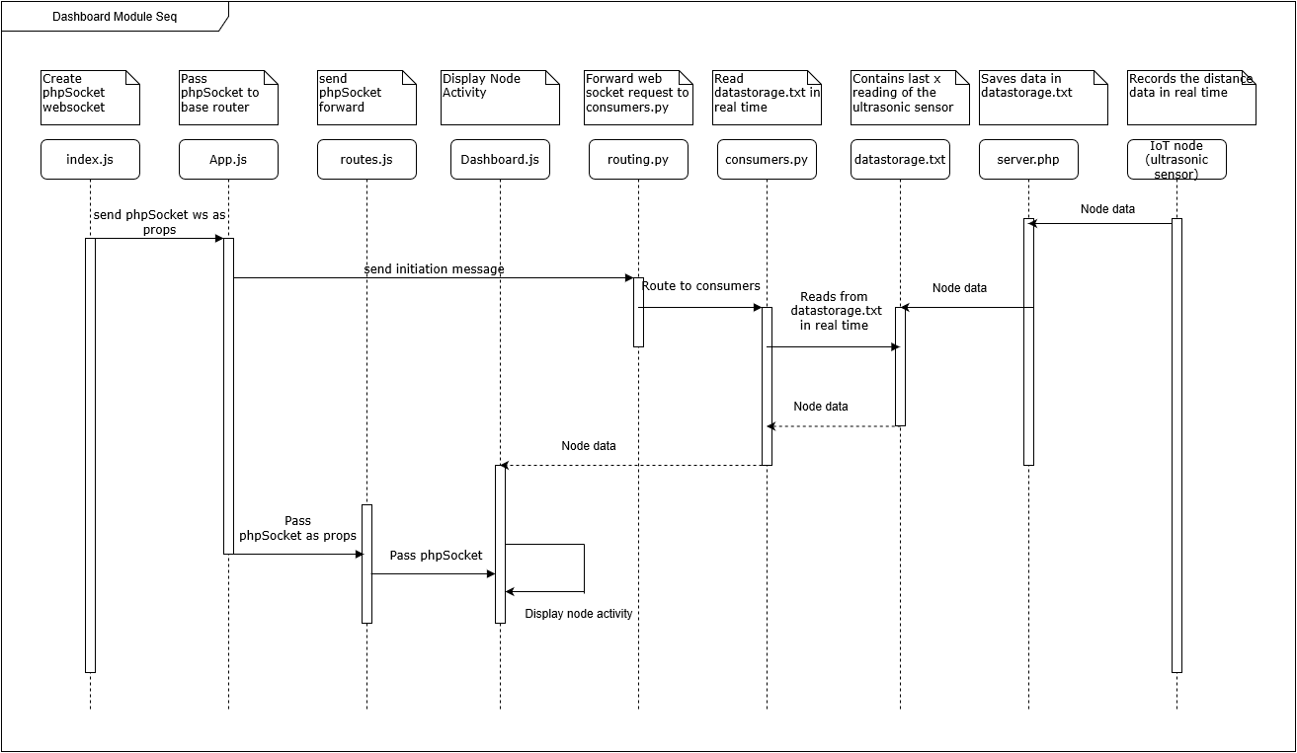
Fig 4.4 Dashboard Module

4.2.8 Visualisations
Visualisations modules showcases the data exploration, preprocessing and comparisons in results from the dataset and ML model. It has the visuals – ML model comparison, types of attack, types of protocol, correlation matrix, confusion matrix, effects of oversampling. The results were obtained in the python files dataFilteration.py, resampling.py, modelCompare.py, dataVisual.py and displayed in the visualisations module. This can be better understood from the following sequence diagram.
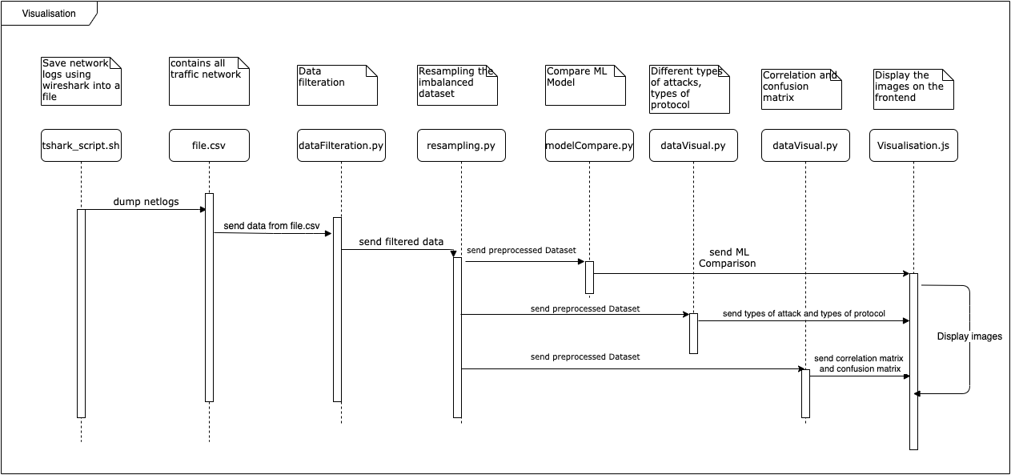
Fig 4.5 Visualisations Module
4.3 Code Listing

The code for this project is available on https://github.com/s3r-be. Following are important snippets of code from the modules of the project.

4.3.1 IoT Node
4.3.1.1 Arduino UNO
// send the ultrasonic wave
// Sets the trigPin on HIGH state for 10 micro seconds
digitalWrite(trigPin, HIGH);
delayMicroseconds(10);
digitalWrite(trigPin, LOW);

// Reads the echoPin, returns the sound wave travel time in microseconds
duration = pulseIn(echoPin, HIGH);

// Calculating the distance
distance= duration*0.034/2;
ArduinoUno.print(distance);
ArduinoUno.println("\n");
Serial.println(distance);
delay(100);

4.3.1.2 Node MCU
// connecting to wifi
WiFi.begin(ssid,password);
Serial.println();
Serial.print("Connecting");
while( WiFi.status() != WL_CONNECTED ){
delay(500);
Serial.print(".");
}

// send distance data to server.php
if (WiFi.status()==WL_CONNECTED)
{
HTTPClient http;
String url="http://" + ip + "/ids/server.php?data="+d;
http.begin(url);
http.addHeader("Content-Type","text/plain");
int httpCode=http.GET();
String payload=http.getString();
Serial.println("While sending I received this from server : "+payload);
if (payload=="SUCCESS. Data written in file."){
sres=1;
} else {
sres=0;
Serial.println("wrong or no payload!");
}
http.end();
net=1;
}

4.3.2 TShark script
#!/bin/bash

echo s3rbeproj | sudo -S `#to get sudo permissions`\
tshark `#run tshark`\
-T fields -e frame.number -e frame.time -e frame.len -e eth.src -e eth.dst `#give fields to capture`\
-e ip.src -e ip.dst -e ip.proto -e ip.len -e tcp.len -e tcp.srcport -e tcp.dstport -e _ws.col.Info \
-E header=y -E separator="$" -E quote=n -E occurrence=f `#set headers, separator as comma, double quotations, first occurrence`\
> file.csv `#dump into file.csv`\
-i wlp3s0 `#interface wifi`

4.3.3 Apache backend – server.php
// receive data passed to the script
$val = $_GET["data"];
$fileContent=$val."\n";
$filename = "datastorage.txt";
// append data to datastorage.txt
$fileStatus=file_put_contents($filename,$fileContent,FILE_APPEND);
if($fileStatus != false)
{
echo "SUCCESS. Data written in file.";
$file = file($filename);
// remove first value (to control file size)
unset($file[0]);
file_put_contents($filename, $file);
}

4.3.4 ML Model
for i in range(0,c):
if(l[i].startswith("GET / HTTP/1.1 ")):
num.append("-99")
elif (l[i].startswith("GET")): ###### wrong setup and data type probing
a = l[i].split("=")
b = (a[1].split(" "))
num.append(b[0])
elif(l[i].startswith("Echo")): ######### ddos
num.append("-1")
elif (l[i].startswith("Who")): ############# scan
num.append("-1")

elif "duplicate " in l[i]: ############# mitm
num.append("-1")
else:
num.append("-99")
i+=1

4.3.5 Notification
# previous values to check if attack logging is being repeated
prev_mac_source = ''
prev_mac_dest = ''
prev_prediction = 0

# receive message sent from front end
text_data_json = json.loads(text_data)
message = text_data_json['message']

# Returns the Path your .py file is in
workpath = os.path.dirname(os.path.abspath(__file__))
logfile = open(os.path.join(workpath, "file.csv"), "r")

# check if file.csv is populated, number of lines should be greater than 1
while(len([line for line in logfile]) <= 1):
continue

loglines = self.follow(logfile) # create object of the generator
# for loop runs the generator code in every iteration
# once it reaches yield, it returns the line

for line in loglines:
returnLog = line # storing in temp var to return as log
line = line.split('$')
# line contains data separated with $
# the number of columns is 13
# however some dataframes will show len < 13 because the data is written incompletely by tshark
# every few seconds 1 dataframe will be dropped

if len(line) == 13:

line[1] = line[1].split(' ')[3].replace(
':', '').replace('.', '') # pre time
line[3] = int(line[3].replace(':', ''), 16) # pre eth src
line[4] = int(line[4].replace(':', ''), 16) # pre eth dst
try:
line[5] = float(line[5].replace('.', '')) # pre ip src
except Exception as ex:
line[5] = 0
try:
line[6] = float(line[6].replace('.', '')) # pre ip dst
except Exception as ex:
line[6] = 0
try:
line[7] = int(line[7]) # pre protocol
except Exception as ex:
line[7] = -1
try:
line[8] = int(line[8]) # pre ip length
except Exception as ex:
line[8] = 0
try:
line[9] = int(line[9]) # tcp length
except Exception as ex:
line[9] = 0
try:
line[10] = int(line[10]) # tcp source port
except Exception as ex:
line[10] = 0
try:
line[11] = int(line[11]) # tcp destination port
except Exception as ex:
line[11] = 0
value = -99
if(line[-1].startswith("GET / HTTP/1.1 ")):
value = -99
elif (line[-1].startswith("GET")): # wrong setup and data type probing
a = line[-1].split("=")
try: # if = hasn't been read, index 1 doesn't exist
b = (a[1].split(" "))
try:
# check if float data is sent, if string it is data type probing
value = float(b[0])
except Exception as ex:
value = -3
except Exception as ex:
value = -99
elif(line[-1].startswith("Echo")): # ddos
value = -2
elif (line[-1].startswith("Who")): # scan
value = -4

elif "duplicate " in line[-1]: # mitm
value = -5
else:
value = -99
line[-1] = value

ip_df = pd.DataFrame([line[1:]])
# get classification - attack or normal
prediction = rf_model.predict(ip_df)[0]
if prediction != 0:
# print('attack: ' + str(prediction))
# still a string to this point
returnLog = returnLog.split('$')

# check if attack is being repeated for same mac source and dest
if not (prev_mac_source == returnLog[3] and prev_mac_dest == returnLog[4] and prev_prediction == prediction):

self.send(text_data=json.dumps({
'attack.type': attack_type[prediction],
'frame.number': returnLog[0],
'frame.time': returnLog[1],
'frame.len': returnLog[2],
'eth.src': returnLog[3],
'eth.dst': returnLog[4],
'ip.src': returnLog[5],
'ip.dst': returnLog[6],
'ip.proto': returnLog[7],
'ip.len': returnLog[8],
'tcp.len': returnLog[9],
'tcp.srcport': returnLog[10],
'tcp.dstport': returnLog[11],
'_ws.col.Info': returnLog[12]
}))
# set prev values - to prevent overloading of front end
prev_mac_source = returnLog[3]
prev_mac_dest = returnLog[4]
prev_prediction = prediction

4.3.6 Network Logs
# receive request and start a loop to send network data back
def receive(self, text_data):
text_data_json = json.loads(text_data)
message = text_data_json['message']

# Returns the Path your .py file is in
workpath = os.path.dirname(os.path.abspath(__file__))
logfile = open(os.path.join(workpath, "file.csv"), "r")

# check if file.csv is populated, number of lines should be greater than 1
while(len([line for line in logfile]) <= 1):
continue

loglines = self.follow(logfile) # create object of the generator
# for loop runs the generator code in every iteration
# once it reaches yield, it returns the line

for line in loglines:
line = line.split('$')
# line contains data separated with $
# the number of columns is 13
# however some dataframes will show len < 13 because the data is written incompletely by tshark
# every few seconds 1 dataframe will be dropped

if len(line) == 13:
self.send(text_data=json.dumps({
'frame.number': line[0],
'frame.time': line[1],
'frame.len': line[2],
'eth.src': line[3],
'eth.dst': line[4],
'ip.src': line[5],
'ip.dst': line[6],
'ip.proto': line[7],
'ip.len': line[8],
'tcp.len': line[9],
'tcp.srcport': line[10],
'tcp.dstport': line[11],
'_ws.col.Info': line[12]
}))

4.3.7 Dashboard
d = d.split('\n', 10);
// get first number from datastorage.txt
d = Number(d[0]);
// append to array
movingAvg.push(d)
if (movingAvg.length >= smoothingWindow) {
// removes first value if length reaches smoothing window (eg 10)
movingAvg.shift();
}
// get sum
var tempAvg = 0;
movingAvg.forEach(element => {
tempAvg += element;
});
// get average
tempAvg /= movingAvg.length;
// condition for tempAvg going beyond threshold
if (tempAvg > 1000) {
tempAvg = tempAvg % 1000;
}
this.setState({
pos: tempAvg
});

4.3.8 Visualisations

<Button.Group>
<Button size="mini" color='black' onClick={this.ModelComparison}>Model Comparison</Button>
<Button size="mini" color='black' onClick={this.ConfusionMatrix}>Confusion Matrix</Button>
<Button size="mini" color='black' onClick={this.Correction}>Correlation Matrix</Button>
<Button size="mini" color='black' onClick={this.WithOverProtocol}>Protocol(Oversampled)</Button>
<Button size="mini" color='black' onClick={this.WithoutOverProtocol}>Protocol</Button>
<Button size="mini" color='black' onClick={this.OAttackDis}>Attacks(Oversampled)</Button>
<Button size="mini" color='black' onClick={this.AttackDis}>Attacks</Button>
<Button size="mini" onClick={this.Disable}> Disable</Button>
</Button.Group>

4.4 Screen shots

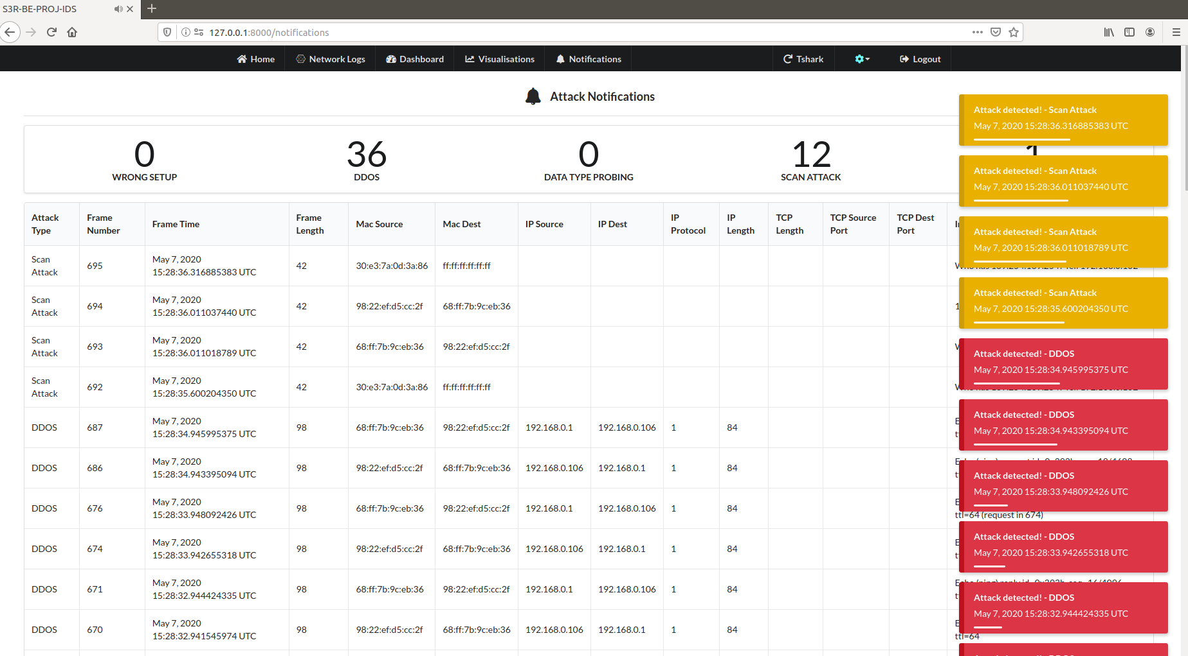
Fig 4.6 Notifications screen shot

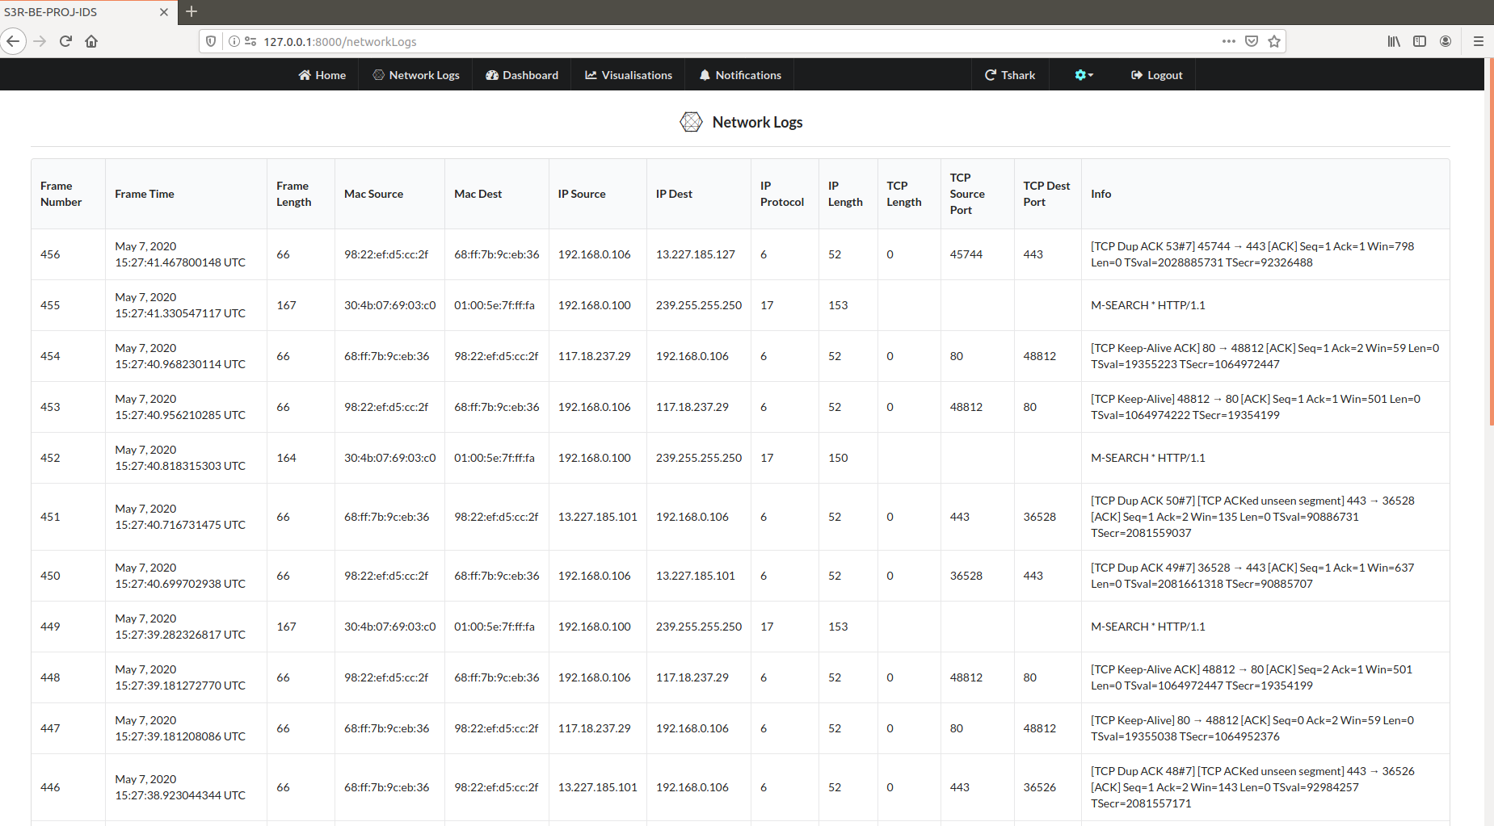
Fig 4.7 Network Logs screen shot

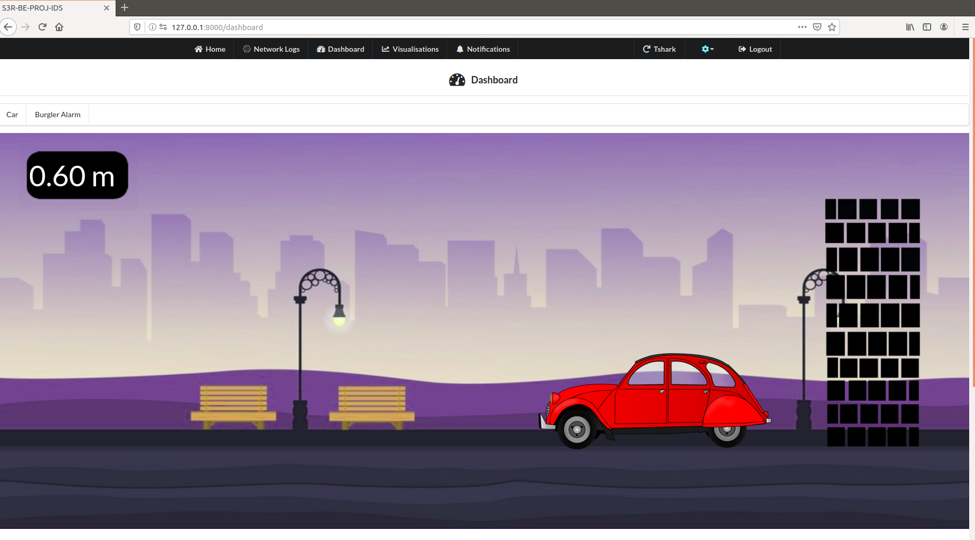
Fig 4.8 Dashboard car screen shot

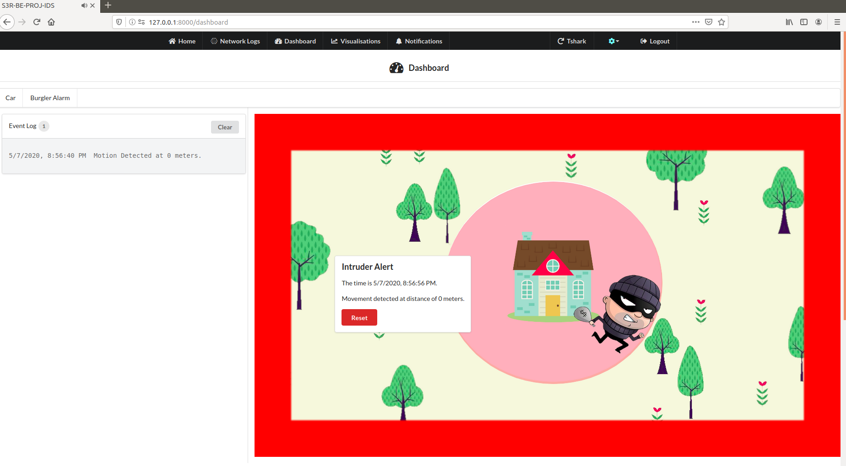
Fig 4.9 Dashboard burglar screen shot

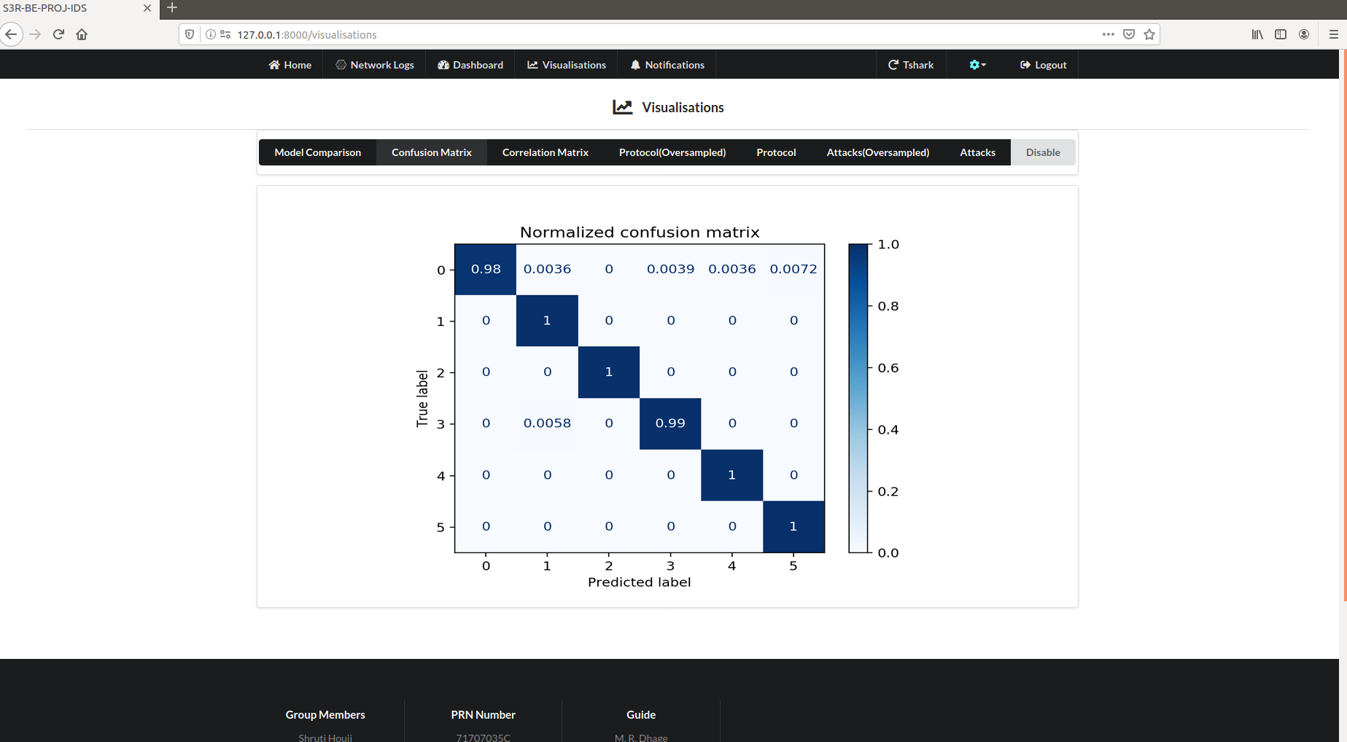
Fig 4.10 Visualisations screen shot

4.5 IoT Node Picture

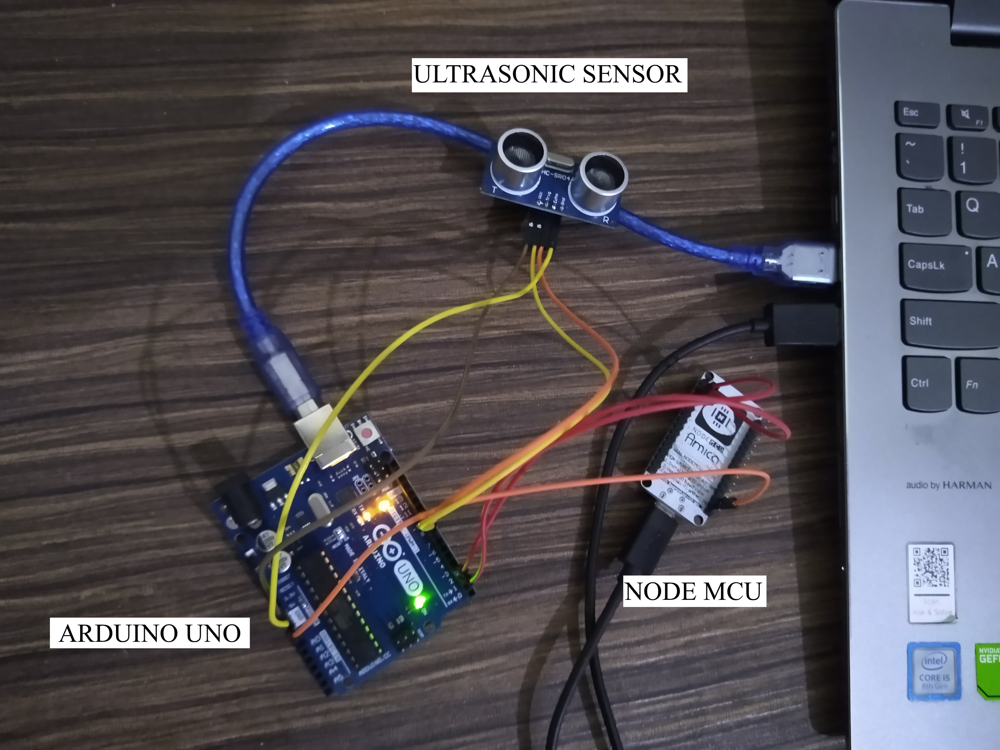
Fig 4.11 IoT Node Picture

Chapter 5

Testing

5.1 Introduction

This chapter covers the testing approach used and the test cases

5.2 Unit Testing

Unit testing is a level of software testing where individual units/ components of a software are tested. The purpose is to validate that each unit of the software performs as designed. A unit is the smallest testable part of any software. It usually has one or a few inputs and usually a single output.

Table 5.1: Unit Testing 1
Title | Login and Authentication check
Test Item | Username, Password, Data packets
Input Specification | Test Item containing alphanumeric characters
Description | Specified details of Login/Register are entered and stored in database
Expected Results | Entry for Test Item is created in Database.
Actual Output | As expected

Table 5.2: Unit Testing 2
Title | Network Connection Check
Test Item | IOT devices, wifi module
Input Specification | Test Item containing alphanumeric characters
Description | Wifi (802.11) protocol is used for connection, communication and sending the sensed data to base station
Expected Results | Data sensed is sent to the server.
Actual Output | As expected

Table 5.3: Unit Testing 3
Title | Intrusion Detection System processing check
Test Item | Sensed based data of specified sensor
Input Specification | Test item containing various ongoing intrusions on IOT network
Description | Intrusion detection data is used to detect malicious attacks on the IOT network and ignore normal behavior of the system
Expected Results | Category of the attack is determined
Actual Output | As expected

Table 5.4: Unit Testing 4
Title | Notification Check
Test Item | Notification page of web application(GUI)
Input Specification | Test Item containing processed data
Description | Alert only for abnormal behavior of the system
Expected Results | Alert to the user on the notification page if malicious attacks are detected
Actual Output | As expected

5.3 Integration Testing

Integration testing is a level of software testing where individual units are combined and tested as a group. The purpose of this level of testing is to expose faults in the interaction between integrated units. Test drivers and test stubs are used to assist in Integration Testing.

Table 5.5: Integration Testing 1
Title | Integration of the IoT node with the system
Description
Description | Data sent from the IoT node is captured in the react FE for display and Django BE for attack classification
Test Steps | Run the IoT node and the web app in the IOT network
Expected Results | IoT Data and Network data displayed on the front end
Actual Output | As expected

Table 5.6: Integration Testing 2
Title | Integration of all modules in web app
Description
Description | Modules Notifications, Dashboard, Network Logs and Visualisations are added in the web app
Test Steps | Run the application program after integration
Expected Results | All modules work correctly i.e. Notifications show when attack is detected, dashboard shows node data, network logs are displayed and visualizations show graphs. The web app should not crash.
Actual Output | As expected
5.4 Acceptance Testing

Acceptance testing is a level of software testing where a system is tested for acceptability. The purpose of this test is to evaluate the system’s compliance with the business requirements and assess whether it is acceptable for delivery.

Table 5.7: Acceptance Testing 1

Title | Sensed Availability data
Description | Ultrasonic sensor is used to sense data and is processed to gather sensed availability data in the database
Expected Output | Sensed Availability data is sent to the base station using the wifi protocol
Actual Output | As expected

Table 5.8: Acceptance Testing 2
Title | Accurate Intrusion Detection
Description | The attack should be correctly detected by the web app whenever it happens in the network
Expected Output | Correct detection of attack in real time functioning of the system is achieved
Actual Output | As expected

Chapter 6

Results and Discussions

6.1 Table of the results/findings or graphs
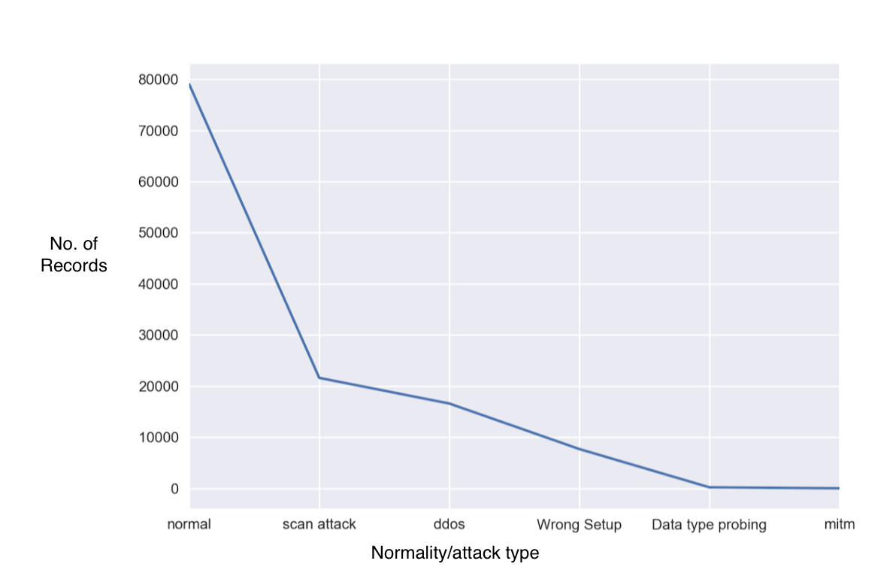
Fig 6.1 Attack distribution
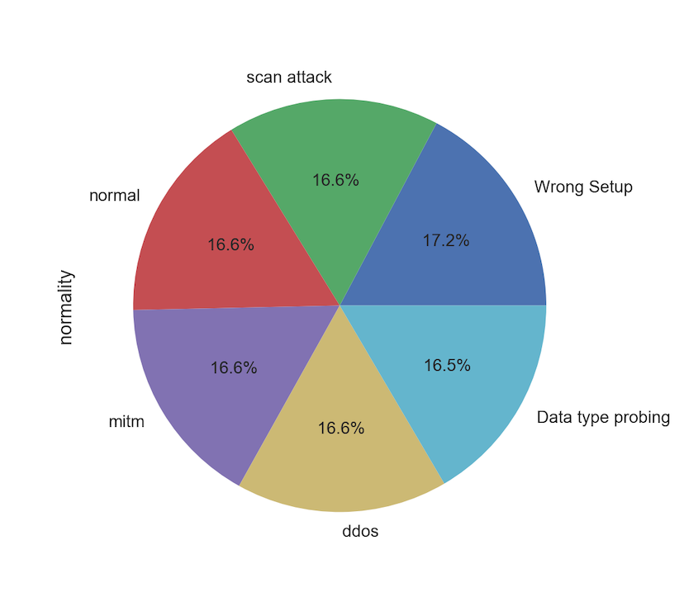
Fig 6.2 Attack distribution post oversampling
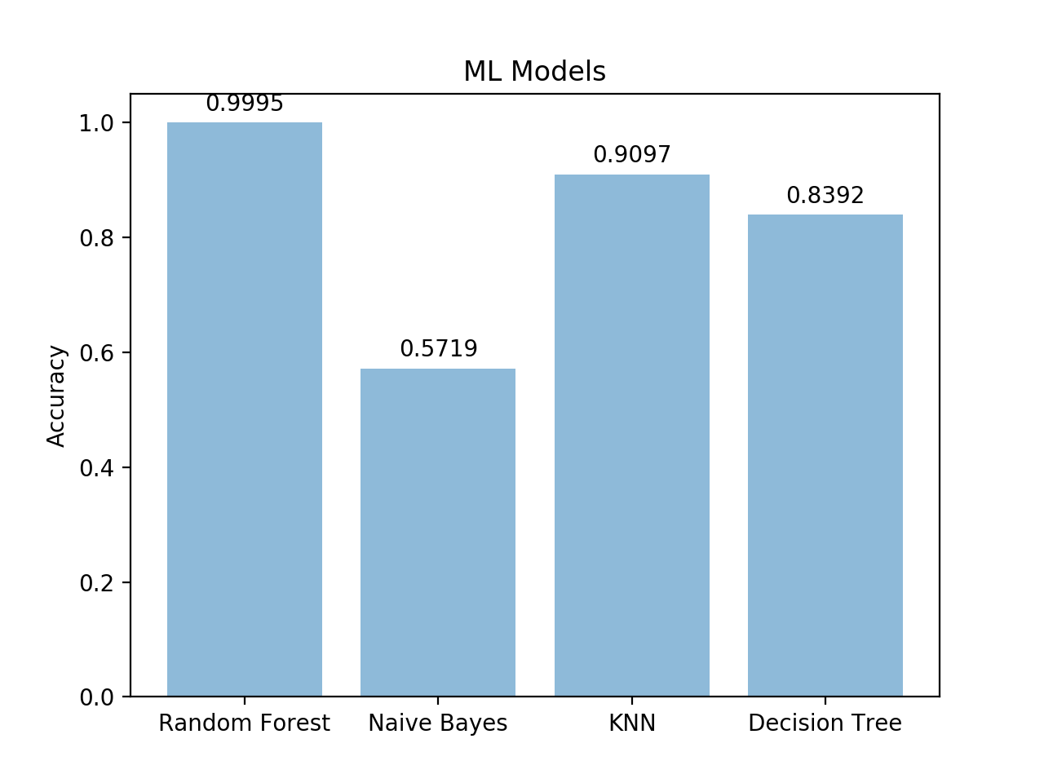
Fig 6.3 Comparison of ML models

6.2 Discussions

The dataset created had a lower number of records labeled as attack as compared to the records labeled as normal as can be seen in fig 1. This issue was resolved by the oversampling done, the results of which can be seen in the fig 2. The Random forest ML model has been proven to be more accurate than other models in comparison – Naïve Bayes, KNN and Decision Tree with an accuracy of 99.95% as compared to the 57.19%, 90.97%, 83.92% respectively as can be seen in fig 3. Although the accuracy seems very high, it has in fact been overfitted on the dataset. This means that even if it shows very high accuracy on training set, it performs poorly on new data. This has given rise to a higher rate of false alarms in the real time working of the IDS. Although this can be an issue, the advantage of this is that even if it has false alarms, it does catch all of the intrusions that occur, thereby giving high true positive rates.

Chapter 7

Conclusion

Intrusion detection systems act as a second line of defense after the firewall and are beneficial for the security of IoT networks. This system has been developed so that can be used in real time IoT networks to improve their security. Using this system, the user can fetch their IoT network data, monitor network traffic, get notified when an intrusion is detected in the network. This has been achieved using the ML model Random Forest. The reduced latency of the system which makes it real time is achieved by web sockets. Since this system is generalized, it can be used for different types of IoT networks to detect intrusions in their network. The model shows a high level of accuracy 99.95%, it correctly classifies most of the attacks in real time, however it suffers from a high rate of false alarms, which is common with these types of models. More work can be done in the future to reduce the false alarm rates and make the model more robust.
References

Journal Article/ IEEE Paper

[1] Abebe A. Diro., Naveen C., ”Distributed attack detection scheme using deep learning approach for Internet of Things”, Future Generation Computer Systems, 82, 2017, 761-768.

[2] Ashima C., Brian L., Sheila F., Paul J., ”Host based Intrusion Detection System with Combined CNN/RNN Model”, IWAISe 2018- ECML PKDD Conference, 2018.

[3] Ebelechukwu N., Andre C., Gedare B., ”Anomaly-based Intrusion Detection of IoT Device Sensor Data using Provenance Graphs”, 1st International Workshop on Security and Privacy for the Internet-of-Things (IoTSec), 2018.

[4] Shadi A., Monther A., Muneer B. Y., ”Anomaly-based intrusion detection system through feature selection analysis and building hybrid eﬃcient model”, Journal of Computational Science, 25, 2018, 152-160.

[5] TagyAldeen M., Takanobu O., Takayuki I., ”Towards Machine Learning Based IoT Intrusion Detection Service”, Recent Trends and Future technology in Applied Intellignece, 2018, 580-585.

